Religious Ed November Newsletter
Please make note of the upcoming important dates and events for the month of November.
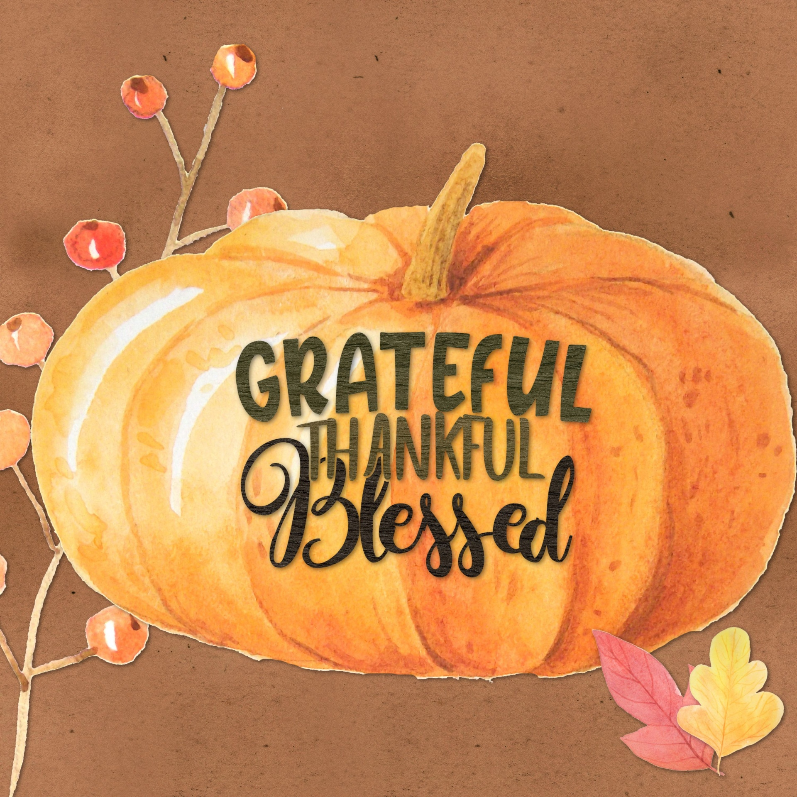

Upcoming Events

November 3
First Penance and Communion meeting in the Church.
6 pm English meeting and 7 pm Spanish meeting.

November 10
Confirmation Year 2 Formation Night 7 pm in the Church.

November 28
Prepare for Advent! RE students will be going to Confession this week.
November 30
Year 1 Confirmation paperwork due.

Important Announcement
Confirmation Year 1 paperwork is due November 28, 29, or 30 depending on when you have class. Please remember to submit the paperwork to the RE teacher.

First Penance and Communion Meeting
On November 3rd we will a mandatory First Penance and First Communion meeting in the Church. We will have two sessions. The 6:00 session will be in English and the 7:00 session will be in Spanish. Please plan to attend as we will discuss the Sacrament, dates, dress code and important information about the special day.
Thanksgiving Food Drive
Your child received a paper asking for donations of canned goods for our annual Thanksgiving food drive.
Rule Reminders
Please be mindful of the following:
- Hats should not be worn inside the building
- Tops should be modest not low cut or cut above the waistline.
- Shorts/skirts should must be no more than 3 inches above the knee.
- Phones and Air Pods/ ear phones are not allowed to be used during class.
Thank you for being respectful.

We will not have Religious Education classes November 21-23rd. Have a wonderful Thanksgiving and we will see you the week of November 28th.

